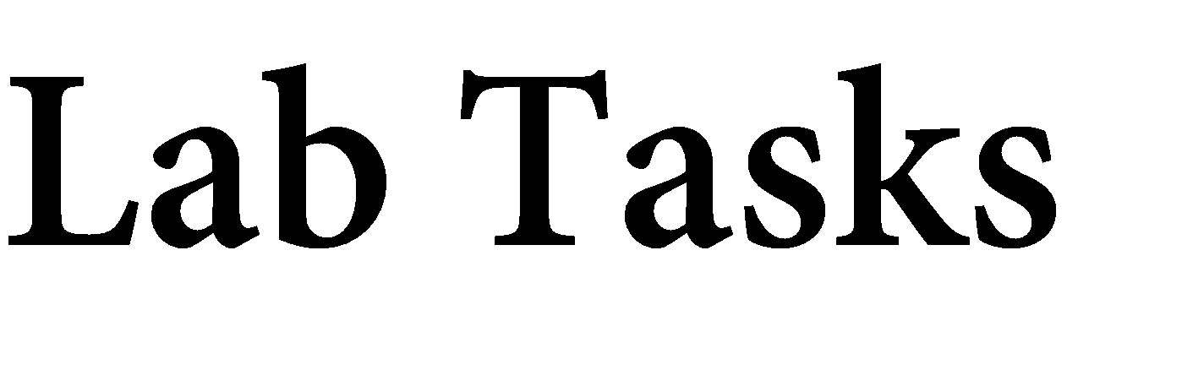

Name: Muhammad Faisal
Roll no: 2022F-BCS-152

Section: A
Instructor Name: Miss Fozia Khan
Course: Artificial Intelligence Lab (CS - 325L)
Program: (BS) - Computer Science

Lab #02

Activity- 1:
Write a Python script that uses a dictionary to store information about a person you know. Store their first name, last name, age, and the city in which they live. You should have keys such as first_name, last_name, age, and city. Print each piece of information stored in your dictionary.
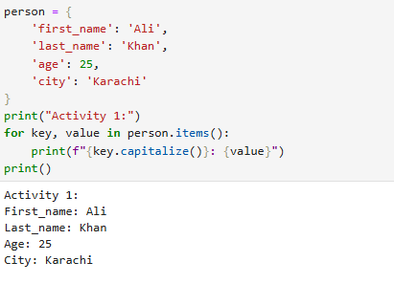

Activity- 2:
Write a function that accepts a dictionary as an argument. If the dictionary contains replicate values, return an empty dictionary, otherwise, return a new dictionary whose values are now the keys and whose keys are the values.
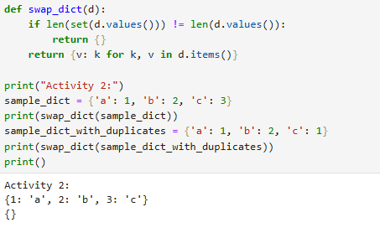

Activity- 3:
A buffet-style restaurant offers only five basic foods. Think of five simple foods, and store them in a tuple.
- Use a for loop to print each food the restaurant offers.
- Try to modify one of the items, and make sure that Python rejects the change.

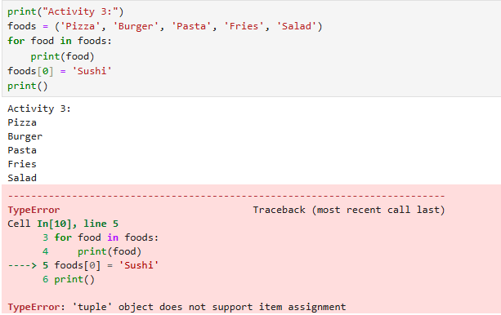

Activity- 4:
If you could invite anyone to dinner. Make a list that includes at least three people you’d like to invite to dinner. Then use your list to print a message to each person, inviting them to dinner.
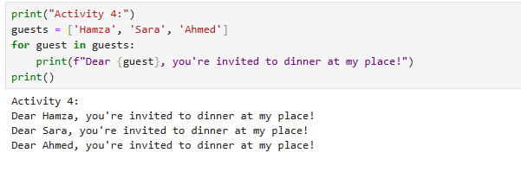

Activity- 5:
Changing Guest List: You just heard that one of your guests can’t make the dinner, so you need to send out a new set of invitations. You’ll have to think of someone else to invite.
- Modify your list, replacing the name of the guest who can’t make it with the name of the new person you are inviting.
- Print a second set of invitation messages, one for each person who is still in your list.
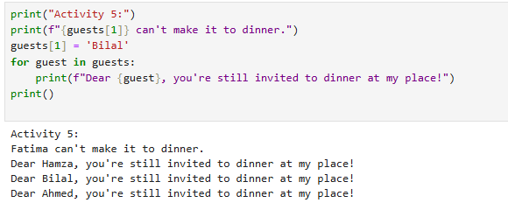

Activity- 6:
Write a program to read 6 numbers and create a dictionary having keys EVEN and ODD.
Dictionary's value should be stored in list. Your dictionary should be like: {'EVEN':[8,10,64], 'ODD':[1,5,9]}
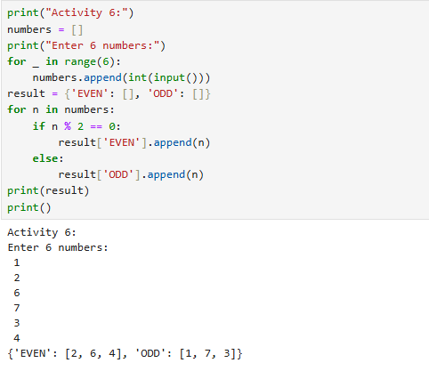

Activity- 7:
Write a definition of a method count_now(places) to find and display those place names, in which there are more than 5 characters.
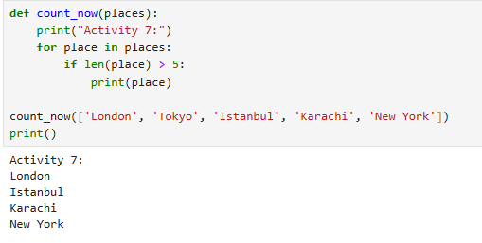

Activity- 8:
Write the following 2 functions: def ComputeOddSum(num): def ComputeEvenSum(num):

- The function ComputeOddSum find the sum of all odd numbers less than num.
- The function ComputeEvenSum find the sum of all even numbers less than num.

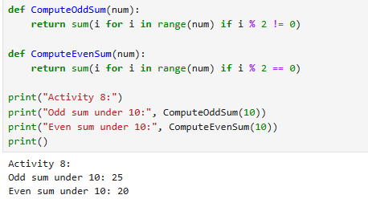

Activity- 9:
Write a recursive function to get sum of all number from 1 up to give number. Example N = 5 Result must be sum (1+2+3+4+5) =15.
